

American International University-Bangladesh (AIUB)  
**Department of Computer Science  
Faculty of Science & Technology (FST)**

**Online Furniture Management System**

A Software Requirement Engineering Project Submitted

By

|  |  |  |  |  |
| --- | --- | --- | --- | --- |
| **Semester: Spring_22_23** | | **Section: G** | **Group Number: 08** | |
| SN | Student Name | Student ID | Contribution (CO1+CO2) | Individual Marks |
| 21 | MD. Abrar Shariar Life | 20-42876-1 |  |  |
| 31 | Aritra Bhowmick | 20-43249-1 |  |  |
| 35 | MD. Mashadul Kabir Tuhin | 20-43450-1 |  |  |
| 36 | MD. Mainul Hasan Plabon | 20-43451-1 |  |  |
|  |  |  |  |  |

The project will be Evaluated for the following Course Outcomes

|  |  |  |
| --- | --- | --- |
| Evaluation Criteria | Total Marks (50) | |
|  | |
| Introduction, Format, Submission, Defense | [10 Marks] |  |
| System Overall Description & Functional Requirements | [10 Marks] |  |
| System Quality Attributes and Project Requirements | [10 Marks] |  |
| UML and E-R Diagram with Data Dictionary | [10 Marks] |  |
| UI/UX Prototyping | [10 Marks] |  |

Software Requirements Specification

for

<Online Furniture Management System>

Version 1.0 approved

Prepared by <MD. Abrar Shariar Life [20-42876-1]

Aritra Bhowmick [20-43249-1]

MD. Mashadul Kabir Tuhin [20-43450-1]

MD. Mainul Hasan Plabon [20-43451-1]>

<FurniTrack>

<30-04-2023>

Table of Contents

Revision History 4

1. Introduction 4

1.1 Purpose 4

1.2 Document Conventions 5

1.3 Intended Audience and Reading Suggestions 5

1.4 References 5

2. Overall Description 6

2.1 Product Perspective (Business Requirements) 6

2.2 Product Functions 6

2.3 User Classes and Characteristics 7

2.4 Operating Environment 7

2.5 Design and Implementation Constraints 7

2.6 User Documentation 8

3. System Requirements 8

3.1 System Features 8

3.2 Non-Functional/Quality Requirements 13

3.3 Project Requirements 15

4. Interface Requirements 16

4.1 UML 16

4.2 Data Dictionary 19

4.3 UI/UX Design Specification 21

# 

# Revision History

|  |  |  |  |
| --- | --- | --- | --- |
| **Name** | **Date** | **Reason for Changes** | **Version** |
| Introduction, Overall Description | 31-03-2023 | Information was incomplete | Version 1.0 |
| System Requirements, Interface Requirements | 26-04-2023 | System and Interface requirements were not completed. | Version 1.0 |

# Introduction

## Purpose

A furniture management system is a software solution designed to help businesses manage and track their furniture inventory. It enables organizations to efficiently manage their furniture assets, including chairs, desks, cabinets, and other furniture items, by providing tools for tracking, organizing, and allocating furniture resources. The system typically includes a database that stores information about each furniture item, such as its location, condition, purchase date, and maintenance history. It also includes features such as inventory management, scheduling, and reporting, which enable businesses to optimize the use of their furniture resources, reduce costs, and improve operational efficiency.

The scope of the furniture management system includes all aspects of managing and tracking furniture assets within an organization. This includes the following:

**1.** Furniture inventory management

**2.** Asset tracking and monitoring

**3.** Furniture allocation and scheduling

**4.** Reporting and analytics

The software being specified is a furniture management system that is designed to help businesses efficiently manage and track their furniture inventory. The primary purpose of this software is to provide a comprehensive solution for managing furniture assets, including chairs, desks, cabinets, and other items

In furniture management system, the scope document may include the following:

**1. Objectives and goals:** The scope document should clearly state the objectives and goals of the furniture management system. This may include improving furniture asset tracking and management, optimizing resource allocation, reducing costs, and enhancing productivity.

**2. System features:** The scope document should list the key features and functionalities of the furniture management system. This may include furniture inventory management, asset tracking and monitoring, furniture allocation and scheduling.

**3. Stakeholders:** The scope document should identify the stakeholders involved in the project, including the project team, end-users, and any external parties such as vendors or suppliers.

## Document Conventions

One standard is to use a consistent font throughout the document, typically a legible serif or sans-serif font such as Times New Roman or Arial. The font size should also be consistent, typically between 10 and 12 points. Another convention is to use headings and subheadings to organize the document and make it easier to navigate. The headings should be formatted consistently, using a larger font size, boldface, or other formatting to make them stand out. Bullet points or numbered lists may also be used to break up long paragraphs and make the document more readable. In terms of highlighting, some SRS documents may use bold or italic text to emphasize key points or requirements. However, it's important to use highlighting sparingly and consistently to avoid confusion. Overall, the goal of following standards and typographical conventions in an SRS is to ensure that the document is clear, consistent, and easy to read and understand.

## Intended Audience and Reading Suggestions

**1. Developers:** Developers are responsible for designing and implementing the software, so they need a detailed understanding of the technical requirements and specifications.

**2. Project Managers:** Project managers are responsible for overseeing the development process and ensuring that the project meets its goals and objectives.

**3. Marketing Staff:** Marketing staff may use the SRS document to understand the key features and functionalities of the software and to develop marketing materials and strategies.

**4. Users:** Users are the end-users of the software and may refer to the SRS document to understand how to use the software and what features are available.

**5. Testers:** Testers are responsible for testing the software to ensure that it meets the specified requirements. They may use the SRS document to develop test cases and test plans.

**6. Documentation Writers:** Documentation writers are responsible for creating user manuals, help files, and other documentation to assist users in using the software.

## References

1. <https://pdfcoffee.com/furniture-management-system-pdf-free.html>

2. <https://phpgurukul.com/online-furniture-shop-management-system-using-php-and-mysql/>

3. <https://codebun.com/uml-diagrams-for-online-furniture-shop-system-project/>

4. <https://www.lovelycoding.org/furniture-management-system/>

# Overall Description

## Product Perspective

Business requirements for the furniture management system include inventory management, sales and order management, reporting and analytics, integration with existing systems, and a user-friendly interface. These requirements are derived from the company's strategic plans and guide the development of the software. Efficient tracking and management of inventory levels, a centralized platform for managing customer orders and tracking sales data, and robust reporting and analytics capabilities are key features of the system. Integration with existing systems and a user-friendly interface are also important considerations to ensure that the software meets the needs of the company and supports its strategic goals.

The furniture management system is a new, self-contained software product being developed to support the furniture business's operations. It is not a replacement for any existing systems but is designed to provide more efficient and streamlined management of inventory, sales, and reporting. The system will be a standalone product, but it will also interface with existing systems within the company, such as accounting software, ERP systems, and other relevant tools. The furniture management system will consist of several major components, including an inventory management module, a sales and order management module, and a reporting and analytics module. These modules will work together to provide a comprehensive platform for managing the company's furniture operations. The system will interface with existing systems through standard APIs and data exchange protocols, ensuring that data can be easily shared across different departments and systems. A diagram that shows the major components of the overall system, subsystem interconnections, and external interfaces can be helpful in understanding how the furniture management system fits into the larger business ecosystem.

## Product Functions

The major functions that the furniture management system must perform or let the user perform:

* **Inventory Management**: The system must track and manage furniture inventory, including stock levels, product details, and location.
* Sales and Order Management: The system must support the management of sales and orders, including customer management, order processing, and invoicing.
* **Reporting and Analytics**: The system must provide reporting and analytics functionality, including sales reports, inventory reports, and financial reports.
* **User Management:** The system must manage user access and permissions to ensure security and data privacy.
* **Integration with External Systems:** The system must interface with external systems such as accounting and supply chain management systems.
* **System Administration:** The system must provide administrative tools for managing the system's configuration, backups, and system updates.

## User Classes and Characteristics

* **Customers:** The customers are the end-users who purchase furniture from the software. They will use the system to place orders, track order status, and manage their account information. They may have varying levels of technological proficiency and may access the system through multiple devices such as desktops, laptops, tablets, and smartphones.
* **Sellers:** The sellers are the manufacturers, wholesalers, or retailers who supply furniture to the software. They will use the system to manage product information, update pricing, and track product availability. They may also access the system to view purchase orders and manage delivery schedules.
* **Furniture owners:** The furniture owners are the end-users of the system, who purchase and use the furniture products sold by the software. They may use the system to browse products, view product details and pricing, place orders, and track their order status.
* **Admin:** The Admin is an internal user of the furniture management system who has access to the back-end of the system. They are responsible for managing the system's functionality, such as adding, modifying, or deleting products, managing customer data, and updating the system's configuration settings. They may also generate reports on the system's performance and monitor system activity

## Operating Environment

The operating environment of the furniture management system is an essential aspect of the software's development process. The system must be designed to operate seamlessly in the following environment:

* **Hardware platform:** The software will run on standard desktop and laptop computers, which must meet the minimum hardware requirements for the software to operate efficiently. This may include minimum processor speed, memory, and storage capacity.
* **Operating system:** The software will be compatible with Windows, Mac, and Linux operating systems. The minimum version requirements will be communicated to the users.
* **Software components:** The software must be compatible with other software applications, including web browsers and database management systems.
* **Network:** The system will be connected to a local network to allow for communication between the different users of the system, such as the customers and sellers. The network must be secure to prevent unauthorized access to the system.

## Design and Implementation Constraints

The following are the design and implementation constraints for the furniture management system software:

* The software must be developed using Java programming language.
* The software must be able to integrate with existing inventory and accounting software used by the company.
* The software must be able to run on Windows and Mac operating systems.
* The software must be designed to handle large volumes of data and transactions.
* The software must follow standard security protocols to protect sensitive customer and business data.
* The software must adhere to coding standards and documentation guidelines specified by the company.
* The software must be modular in design to allow for future enhancements and updates.

## User Documentation

The user documentation components that will be delivered with the furniture management system software include:

* **User manual:** This will provide a detailed guide on how to use the software, including step-by-step instructions on how to perform specific tasks, and information on the features and functions of the software.
* **Online help:** This will provide context-sensitive help for users while they are using the software. It will provide information on specific topics, including how to perform specific tasks, how to navigate through the software, and how to troubleshoot issues.
* **Tutorials:** These will provide interactive guides that will walk users through specific tasks or scenarios. They will be designed to help users quickly learn how to use the software and its features.

# System Requirements

## System Features

**Functional Requirements (FRs)**

**1. Software Login**

* 1. The software shall allow users to login with their given username and password.
  2. The login credentials (username and password) will be verified with database records.
  3. If the login successful, the home page of the user account will be displayed.
  4. If the username and/or password has been inserted wrong, the random verification code will be generated and sent to the user’s email address by the system to retry login.
  5. If the number of login attempt exceed its limit (3 times), the system shall block the user account login for one hour *[optional function]*

**Priority Level:** High **Precondition:** user have valid user id and password  
**Cross-references:** 2.1, 2.2

**2. Create account**

2.1 The software shall allow users to create an account with a valid email address and password.

2.2 The system shall verify that the email address is not already registered in the system.

2.3 The system shall enforce password complexity rules (such as minimum length, use of special characters, etc.).

2.4 After successful account creation, the system shall send a confirmation email to the user's email address with a link to activate the account.

2.5 If the user does not activate the account within a specified time period (e.g. 24 hours), the system shall delete the account.

**Priority Level:** High **Precondition:** user has a valid email address and internet connectivity.  
**Cross-references:** 1.1, 1.2, 1.3, 1.4, 1.5

**3. Manage/Update profile**

3.1 The software shall allow users to manage/update their profile information such as name, email, contact information, and password.

3.2 The system shall validate the user's new password based on certain password criteria (such as minimum length, complexity requirements).

3.3 Users shall be able to upload a profile picture or avatar. Users shall be able to view their profile information after updating it.

3.4 The system shall send a notification to the user's email address when any changes to the profile information are made.

3.5 The system shall allow users to reset their password using a forgot password feature.

3.6The system shall encrypt sensitive profile information (such as passwords) to protect user privacy.

**Priority Level:** High **Precondition:** user is logged in and has access to the "Manage Profile" feature  
**Cross-references:** 1.1, 1.2, 1.3

**4. View items**

4.1 The system shall display a list of available items on the home page.

4.2 The list of items shall include the item name, description, price, and image.

4.3 The system shall allow the user to filter the items based on category, price range, and availability.

4.4 The system shall allow the user to sort the items based on price, popularity, and rating. 4.5 The user shall be able to click on an item to view its detailed information.

4.6 The detailed information of an item shall include the item name, description, price, image, rating, reviews, and related items.

4.7 The system shall allow the user to add an item to the shopping cart from the item details page.

**Priority Level:** High **Precondition:** User is logged in to the system and has accessed the home page.  
**Cross-references:** 1.1, 1.2, 1.3

**5. Add to cart**

5.1 The software shall allow users to add items to their shopping cart.

5.2 The shopping cart shall display the added items and the total cost.

5.3 The software shall provide an option to update the quantity of each item in the shopping cart.

5.4 The software shall provide an option to remove items from the shopping cart.

**Priority Level:** High **Precondition:** User has logged in and is viewing a product page.  
**Cross-references:** 1.1, 1.2, 1.3, 4.1, 4.2, 4.3, 4.4, 4.5, 4.6, 4.7

**6. Confirm order**

6.1 The system shall display an order confirmation screen after the user selects "Confirm Order" from the shopping cart screen.

6.2 The order confirmation screen shall display a summary of the items being ordered, including product name, quantity, and total price.

6.3 The user shall be able to review and modify the order details on the confirmation screen before submitting the order.

6.4 The system shall calculate the total cost of the order, including any applicable taxes, shipping fees, and discounts.

6.5 The user shall be prompted to enter their shipping address and payment information.

6.6 The system shall validate the user's payment information before submitting the order.

6.7 Upon successful validation of the payment information, the system shall submit the order to the seller for processing.

6.8 The user shall receive an order confirmation email containing the order details, estimated delivery date, and a unique order number.

**Priority Level:** High **Precondition:** User has added items to their shopping cart and has entered valid shipping  
**Cross-references:** 1.1, 1.2, 1.3, 5.1, 5.2, 5.3, 5.4

**7. Add furniture name, price and image**

7.1 The software shall allow sellers to add furniture items with their name, price, and image. 7.2 The name and price fields will be mandatory, while the image field will be optional.

7.3 Sellers can upload an image of the item by browsing their local device or providing an image URL.

7.4 The software shall verify that the entered price is a valid number.

7.5 The software shall allow sellers to specify additional details such as item dimensions, materials, and descriptions.

7.6 Sellers can edit the details of the added furniture items at any time.

7.7 Sellers can delete any added furniture items that are not sold or part of any confirmed.

**Priority Level:** High **Precondition:** seller is logged in to the system  
**Cross-references:** 1.1, 1.2, 1.3

**8. Manage products**

8.1 The system shall allow the administrator to add new furniture products by specifying the product name, price, description, and an image.

8.2 The system shall allow the administrator to edit existing furniture products by modifying the product information, including the product name, price, description, and image.

8.3 The system shall allow the administrator to delete existing furniture products from the system's database.

8.4 The system shall provide a search function that allows the administrator to search for specific furniture products in the system's database based on the product name or other criteria.

8.5 The system shall maintain a history of changes made to each furniture product in the system's database, including the date and time of each change and the administrator who made the change.

**Priority Level:** High **Precondition:** Admin is logged in  
**Cross-references:** 1.1, 1.2, 1.3

**9. Manage Users**

9.1 Add new user: The system should allow an administrator to add a new user to the system by providing their personal information, such as name, email address, and password.

9.2 Update user information: The system should allow an administrator to modify user information such as name, email address, and contact information.

9.3 Delete user: The system should allow an administrator to remove a user from the system. 9.4View user information: The system should allow an administrator to view the details of a user's account, including personal information, account status, and purchase history.

9.5 User roles and permissions: The system should allow an administrator to define different roles for users and assign permissions based on those roles. For example, an administrator role may have access to all features, while a customer service representative role may only have access to view and update user information.

9.6 User search: The system should allow an administrator to search for users based on different criteria, such as name, email address, or account status.

**Priority Level:** High **Precondition:** The user must be logged in as an administrator  
**Cross-references:** 1.1, 1.2, 1.3

## Non-Functional/Quality Requirements

**QA1: AVAILABITY**: Our application is 100% present available on weekdays.

**Priority Level:** Medium  
**Precondition:** N/A  
**Cross-references:** QA2

**QA2: PERFORMANCE:** Our application can serve 50 thousand people at a time. And our software page load time is maximum 10 sec.

**Priority Level:** Medium  
**Precondition:** N/A  
**Cross-references:** QA1

**QA3: EFFICIENCY:** Our application is light software. It’s use at least 15% of the processor and RAM available to the application at the peak load conditions.

**Priority Level:** Medium  
**Precondition:** N/A  
**Cross-references:** QA2

**QA4: FLEXIBILITY:** Our application can be add new capabilities when it’s needed. We have development team which can able to make a new copy output available to the product, including code modifications and testing, with no more than 10 hours.

**Priority Level:** Medium  
**Precondition:** N/A  
**Cross-references:** QA3

**QA5: INTEGRITY:** Our application Integrity requirements have no tolerance for errors. We accept online payment from our users which can be access by only the admin.

**Priority Level:** Medium  
**Precondition:** N/A  
**Cross-references:** QA-6

**QA6: INTEROPERABILITY:** Our application can easily exchange data or service with other system to provide one-stop services to the users.

**Priority Level:** Medium  
**Precondition:** N/A  
**Cross-references:** QA5

**QA7: PORTABILITY:** Our application is android and web base software. It’s easy to transfer from one device to another or it can be downloaded from our website or play store for free.

**Priority Level:** Medium  
**Precondition:** N/A  
**Cross-references:** QA6

**QA8: REUSABILITY:** Our application’s features functions shall be designed to be reusable at the object code level in other application that use the similar application.

**Priority Level:** Medium  
**Precondition:** N/A  
**Cross-references:** QA7

**QA9: RELIABILITY:** Our application is more reliable furniture management system app than any other furniture management system app in the market. In our test runs of the application only 4 of the 1000 runs are fails.

**Priority Level:** Medium  
**Precondition:** N/A  
**Cross-references:** QA8

**QA10: USABILITY:** Our application is easy to use compare to others. User can choose the default language for the app. And we use symbolic icons to the options to easy to understand for our users.

**Priority Level:** Medium  
**Precondition:** N/A  
**Cross-references:** QA9

**QA11: MAINTAINABILITY:** Our application is easy to maintain. We have a maintenance team which can able to modify or fix the application’s any failure within 24 labor hours.

**Priority Level:** Medium  
**Precondition:** N/A  
**Cross-references:** QA10

**QA12: TESTABILITY:** In our application the maximum cyclomatic complexity of a module shall not exceed 20.

**Priority Level** Medium  
**Precondition:** N/A  
**Cross-references:** QA11

## Project Requirements

1. **Programming Language:** The system can be developed using programming languages such as Java, Python, or PHP.
2. **Relational Database Management System (RDBMS):** An RDBMS such as MySQL, PostgreSQL, or Oracle can be used for storing and managing data.
3. **Web Development Framework:** A web development framework such as Laravel, Django, or Spring Boot can be used to build the web application.
4. **Payment Gateway Integration:** Payment gateways such as Bkash, Nagad, Rocket, Banking, Visa card, Master card can be integrated into the system to enable secure payment processing.
5. **Cloud Hosting Services:** Cloud hosting services such as AWS, Azure, or Google Cloud can be used to host the application and database for scalability and reliability.
6. **Interface Design Tools:** User interface design tools such as Figma, Sketch, or Adobe XD can be used to create a user-friendly interface for the system.

# Design and Interface Requirements

## UML Diagrams

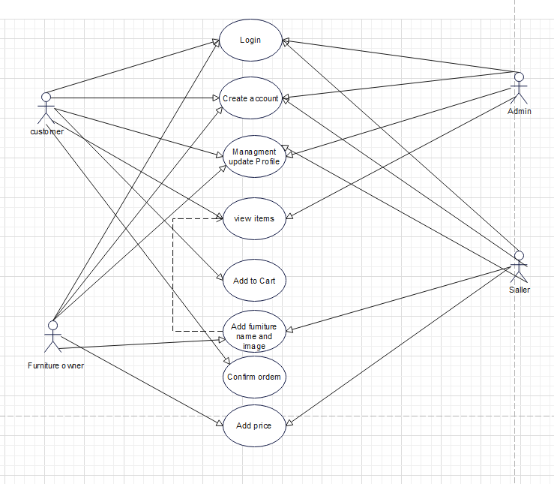

Figure: Use case diagram

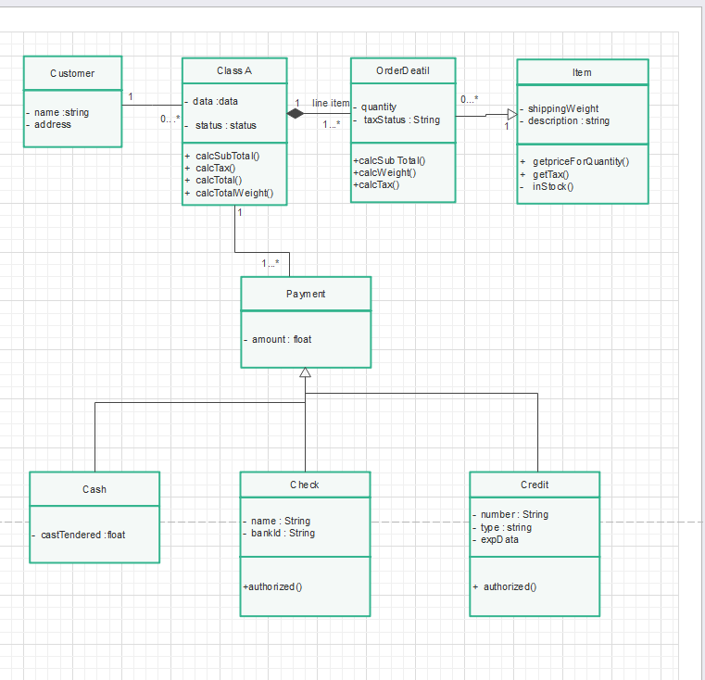

Figure: Class diagram

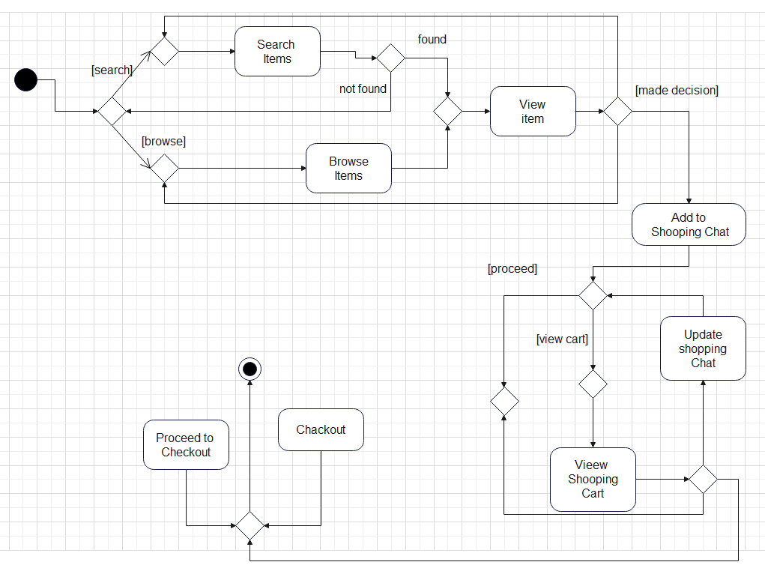

Figure: Activity diagram

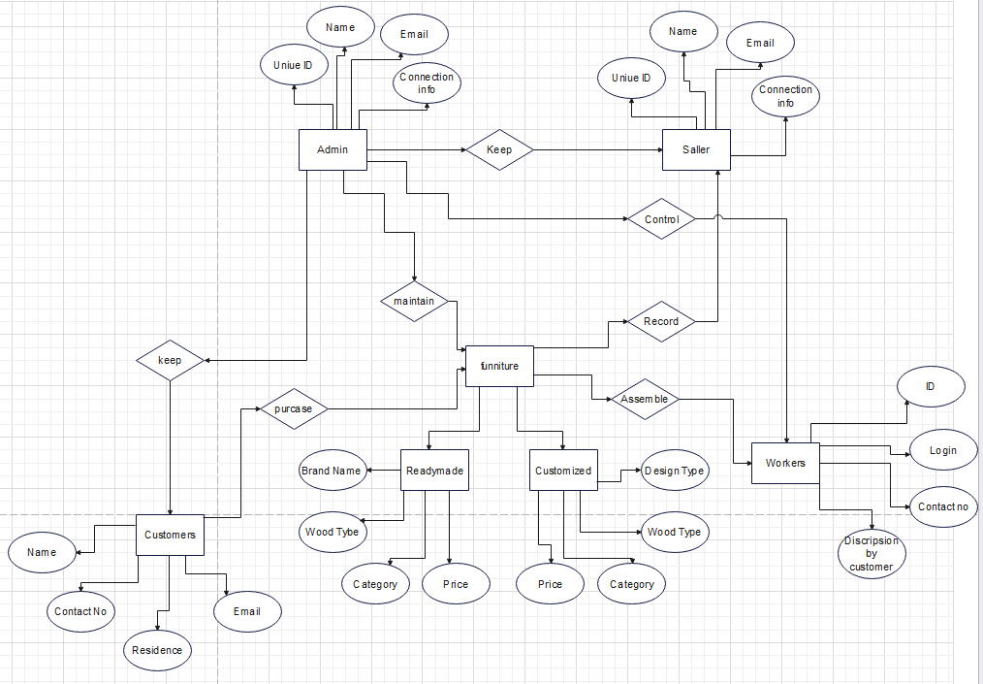

Figure: E-R diagram

## Data Dictionary

For User

|  |  |  |  |  |
| --- | --- | --- | --- | --- |
| Entity | Attribute | Type/Size | Validation | Key |
| User | User ID | Integer | >0 | Primary Key |
| User | First Name | Varchar(50) | Not null, alphabetical |  |
| User | Last Name | Varchar(50) | Not null, alphabetical |  |
| User | Email | Varchar(1000) | Not null, valid email format | Unique Key |
| User | Password | Varchar(50) | Not null, alphabetical |  |
| User | Create At | Date time | Not null, default: current date time |  |
| User | Update At | Date time | Not null, default: current date time on update |  |

For Seller

|  |  |  |  |  |
| --- | --- | --- | --- | --- |
| Entity | Attribute | Type/Size | Validation | Key |
| Seller | ID | Integer | Unique, not null | Primary Key |
| Seller | Name | String(50) | Not null, maximum length 50 |  |
| Seller | Email | String(100) | Not null, must be a valid email format | Unique Key |
| Seller | Password | String | Not null, encrypted/hashed for security |  |
| Seller | Phone | String(15) | must be a valid phone number format |  |
| Seller | Address | String(100) | Maximum length 100 |  |

For Furniture owner

|  |  |  |  |  |
| --- | --- | --- | --- | --- |
| Entity | Attribute | Type/Size | Validation | Key |
| Furniture | ID | Integer | Unique, Auto-increment | Primary Key |
| Furniture | Name | Varchar(50) | Required |  |
| Furniture | Description | Text |  |  |
| Furniture | Price | Decimal(10,2) | Required, Positive value |  |
| Furniture | Image | Varchar(255) |  |  |
| Furniture | Category | Varchar(50) | Required |  |
| Furniture | Date Added | Date | Required, Default to current date |  |

For Admin

|  |  |  |  |  |
| --- | --- | --- | --- | --- |
| Entity | Attribute | Type/Size | Validation | Key |
| Product | Product ID | Integer | Unique, Auto-increment | Primary Key |
| Product | Quantity | Integer | Not null | Primary Key |
| Category | Category ID | Integer | Unique, Auto-increment | Primary Key |
| Order | Order ID | Integer | Unique, Auto-increment | Primary Key |
| Order Detail | Order Detail ID | Integer | Unique, Auto-increment | Primary Key |

## UI/UX Design Specification

**For Customer**

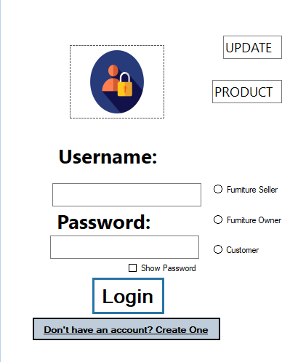 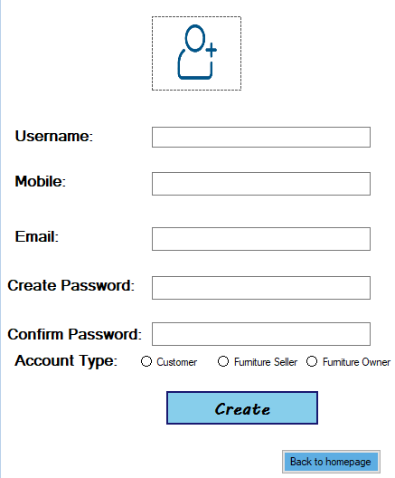

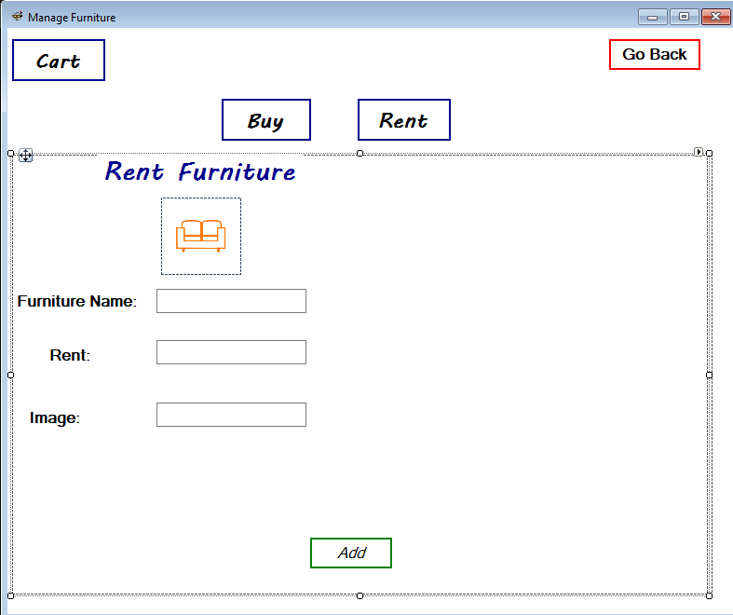

**For Seller**

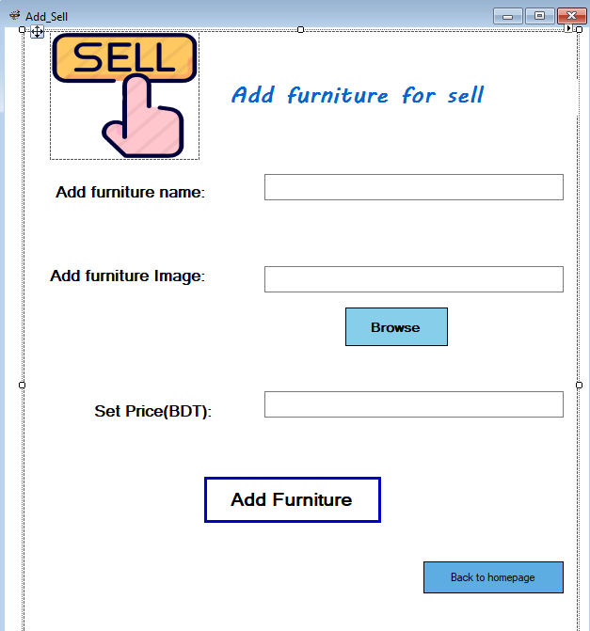

**For Furniture Owner**

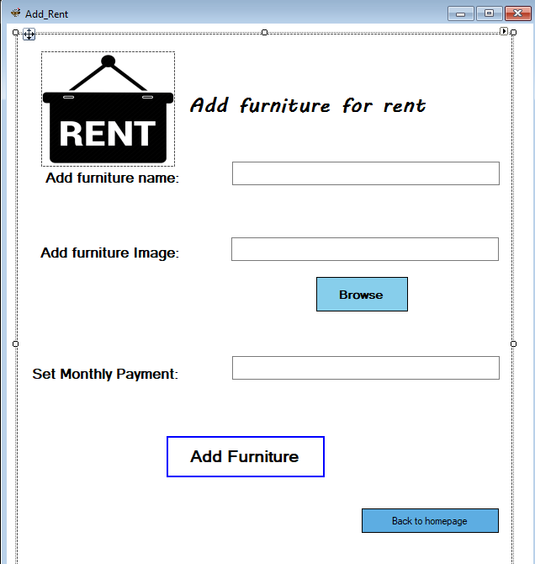

**For Admin**

